Wilson Avenue School Kindergarten Supply List 2026-27

Quantity | Description | Item
4 | 2- Pocket Folders  (1-red, 1-blue, 1-yellow, 1-green)  No PRONGS | 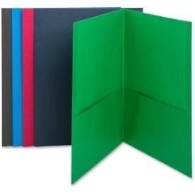
4 | Dry-Erase Markers (8) | 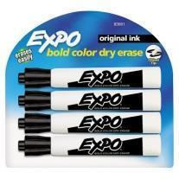
1 | Book Bag  **no wheels** | 
3 | Glue Sticks (large) | 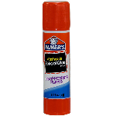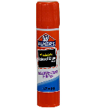
3 | Erasers | 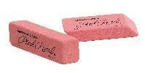
1 | Headphones with microphone | 
2 | Primary Journals | 