Wilson Avenue School
Supply List 2026-2027
Entering First Grade

Welcome to First Grade! The following supplies are required to have a successful year.
Quantity | Item Description | Example
1 | large pencil pouch (no boxes) | 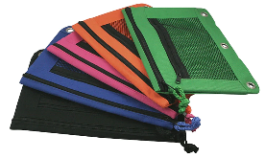
24 | yellow pencils
2 | big erasers | 
2 | 24 count boxes of crayons | 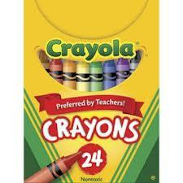
2 | 2 marbled composition notebooks  (wide ruled) | 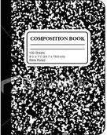
2 | primary journals, half page ruled, grades K-2 | 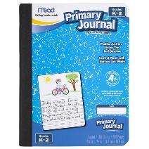
4 | large glue sticks | 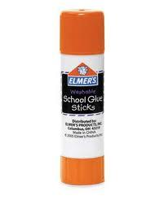
4 | black Expo dry erase markers | 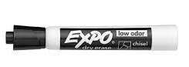
1 | headphones | 
4 | plain colored folders (1 of each color, no pictures, cartoons, etc.) | 