Wilson Avenue School Supply List 2026-2027
Entering Sixth Grade
Item  **some items will need to be replenished throughout the year** | Quantity
Graph paper | 1 pack
Spiral Notebook (1 subject) | 5
Spiral Notebook (2 subject) | 1
Calculator (Scientific) | 1
#2 Pencil 12 pack | 2
Pens (black or blue) 12 pack | 2
Dividers for Binders | 1 package of 5 or more
College Ruled loose leaf lined paper | 1 ream
Loose Leaf Reinforcements (100ct) | 1 pack
3”x5” Lined Index Cards | 2 packs
Ruler (inch - centimeter) | 1
Eraser | 3
Scissors | 1
Sheet Protectors (100ct) | 1 pack
Washable Markers (no Sharpies) | 1 pack
Colored Pencil 24ct. | 1 pack
Pencil Sharpener with cover | 1
Highlighters (blue, pink, yellow) | 3
Wired Earbuds (No bluetooth) | 1
Roget’s 21st Century Thesaurus  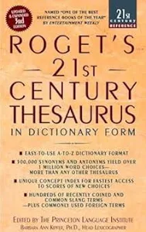 | 1

