Wilson Avenue School Kindergarten Supply List 2019-20
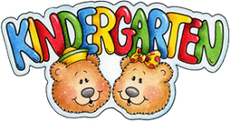
(4) 2- Pocket Folders  (1-red, 1-blue, 1-green, 1- yellow)  NO PRONGS | 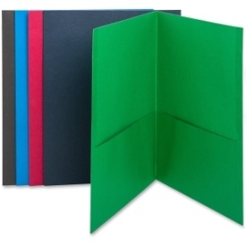
Crayola 24 ct. Crayons
(2) Dry Erase Markers Pack of 4 | 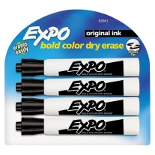
(1) Box of Tissues | 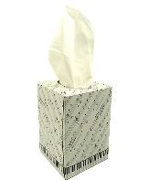
(1) Drawstring Bag
(3) Glue Sticks (large)
(1) Container of Wipes | 