Wilson Avenue School
Summer Reading Assignment
Students Entering 7th Grade
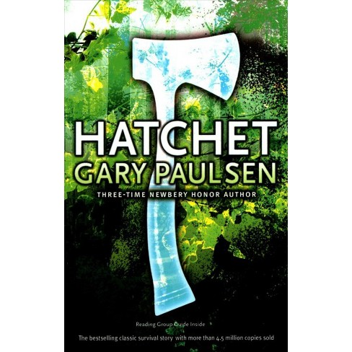
Required Book: Hatchet by Gary Paulson
Required Assignments:
- After reading Hatchet, complete the two assignments below:
I.Comprehension Questions – Complete the questions below. Be sure to answer using complete sentences. Cite evidence from the text to support your responses. Please write or type the answers on a separate sheet of paper neatly.
- Why is Brian flying over the northern wilderness?
- Brian is alone in the wilderness because the pilot had a heart attack. What other reasons does Brian have to feel alone? Use text evidence.
- Why does Brian decide must be done to land the plane?
- Brian is in a fight for his life. What character traits does he need to have any chance of landing the plane safely?
- Where did Brian try to aim the plane for his best chance of landing?
- The first danger Brian had to survive was the plane crash. What dangers do you predict he will have to survive now?
- What was Brian’s first big torment when he woke up to his first day in the wilderness?
- Brian asked why the birds could be singing in the outside world when the world inside his head was so troubled. What does the author want us to know from Brian’s question?
- Where did most of Brians’ knowledge of the wilderness and animals come from?
- What did Brian’s English teacher talk about? How can this help him now?
- What did Brian find that was his first bit of luck in trying to help himself?
- Brian repeatedly talks about keeping his thoughts simple. Why is this so important?
- What does “home” mean to you? What is it about Brian’s shelter that make it his home?
- What was the most important rule of survival that Brian learned?
- Do you think Dad and Terry were really speaking to Brian or was his brain thinking creatively during sleep? Why do you think Brian chose Dad and Terry to speak to him?
- What did Brian have that would make the sparks catch fire and not go out?
- Brian called the fire his friend and guard. What would the fire provide Brian that a friend also provides? In what way could the fire guard him?
- Brian knew to observe and learn from nature. What did he discover when he followed the tracks to the sand?
- Why did the author repeat “He had to keep hoping?”
- How has Brian’s body changing? Give evidence from the text that shows how Brian has grown and changed.
- What did Brian need in order tokeep on trying to play the game?
- How does the saying “necessity is the mother of invention” apply to Bran’s efforts in chapter 12? Explain.
- After Brian woke up after wanting to die, what two true things came to his mind?
- All creatures in the forest are driven by what truly vital knowledge?
- Why was is so important for Brian to learn from his mistakes in his efforts to survive?
- Brian says that so much of living is patience and thinking. Describe your thoughts about this statement.
- What natural event caused the tail of the crashed plane to appear in the lake?
- After the tornado, Bran is once again left with only his hatchet. In what way will rebuilding be different this time? Explain.
- How does Brian accidently discover that he could get into the plane?
- How did people react to Brian’s rescue? Explain your answer with evidence from the text.

II. Explanatory Essay – Essays are to be typed or written neatly on loose-leaf paper in order to receive full credit. Remember to use quotes from the book as support for your ideas, and to cite the page numbers. Use the writing frame to help guide your writing.
Writing Prompt:
Think about how Brian demonstrated leadership abilities and leadership characteristics. In a five paragraph essay, explain how she showed these abilities and characteristics and how his leadership led to or contributed to either a positive or a negative outcome.
In your answer, be sure to:
- Explain his leadership characteristics
- Explain how they led to a positive or negative outcome (choose one)
- Use details and quotes from the book to support your answer
Explanatory Essay Framework
- Introduction Paragraph
- Engaging beginning (Hook)
- Transition from the engaging beginning to the thesis (main idea)
- Thesis statement (your stance and your three reasons)
- Body Paragraph (Leadership Trait #1)
- Topic Sentence Statement (Main Idea Statement)
- Support sentence
- Facts/details
- Elaboration/example
- Details/closure/transition
- Body Paragraph (Leadership Trait #2)
- Topic Sentence Statement (Main Idea Statement)
- Support sentence
- Facts/details
- Elaboration/example
- Details/closure/transition
- Body Paragraph (the positive or negative effect/s of the traits above)
- Topic Sentence Statement (Main Idea Statement)
- Support sentence
- Facts/details
- Elaboration/example
- Details/closure/transition
- Closing Paragraph
- Restate Thesis or Topic Sentences
- Restate main details
- Leave the reader with a powerful concluding thought

