Wilson Avenue School
Summer Reading Assignment
Students Entering 5th Grade
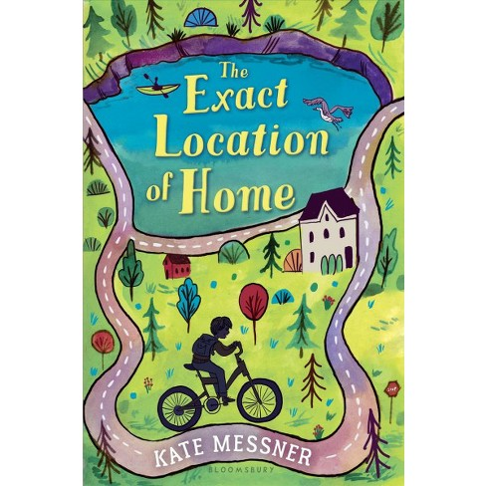
Required Book: The Exact Location of Home by Kate Messner
Required Assignments:
- After reading The Exact Location of Home, complete the questions below:

I.Comprehension Questions – Complete the questions below. Be sure to answer using complete sentences. Cite evidence from the text to support your responses. Please write or type the answers on a separate sheet of paper neatly.
- Zig seems to be excited for his dad’s visit, so why does he tell himself, “Dad’s not coming?” Use text evidence to support your answer.
- What details in the text show you that Zig’s mom is upset about something? Why do you think she is so upset?
- How should Zig handle his discovery about his mom being behind on rent? Should he tell his mother he knows? Why or why not?
- Do you think it’s likely that Senior Searcher is Zig’s dad? Why or why not?
- Why is “Circuit Boy” a good geocaching name for Zig?
- Why is there now a problem with the condominium project on Smugglers Island? Do you think the zoning board should take back their approval? Why or why not?
- How bad is Zig’s mom’s money problem? What do you think they should do?
- Why is Zig trying to track down his dad through geocaching?
- Do you think that Zig should get an additional punishment for leaving in-school suspension? Why or why not?
- How would you describe the teachers at Zig’s school? Look in chapters 16 and 18 and also in previous chapters for details that will help you with your answer.
- What kind of person is Aunt Becka’s husband? Use text evidence to help you describe him.
- Why does Zig’s mom decide to leave her sister’s house earlier that she had planned?
- What surprises Zig about the people he sees at school for free breakfast? What could a person learn from this?
- Do you think Zig’s anger at his mother about staying at the homeless shelter is understandable or fair? Why or why not?
- Why does Zig try so hard to make sure that his friends don’t now he’s not living at his old apartment?
- What do you think will happen when the class brings the donations to the homeless shelter?
- Do you think Zig’s mom should have told Zig the truth about his dad earlier? Why didn’t she?
- Do you think is was reasonable for Zig to have believed Senior Searcher was his dad? Why or why not?
- Why does the author end the book with Zig’s rock skipping across the water?
- What message do you think the author wants the readers to understand after reading this book?

