Wilson Avenue School
Summer Reading Assignment
Students Entering 1st Grade

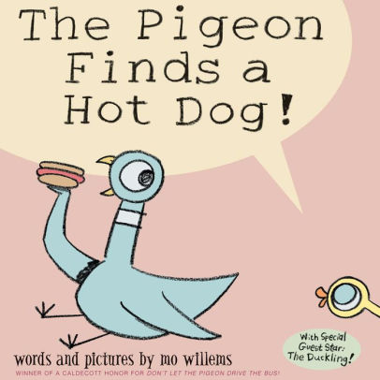

Required Book: The Pigeon Finds a Hot Dog! by Mo Willems
Required Assignment:
- After reading The Pigeon Finds a Hot Dog, complete the following pages!

