Wilson Avenue School
Summer Reading Assignment
Students Entering 4th Grade
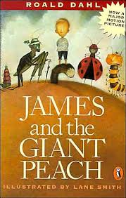

Required Book: James and the Giant Peach by Roald Dahl
Required Assignments:
- After reading James and the Giant Peach, complete the two projects below.
- Map:
- In the novel James travels to any different places and meets many characters in his giant peach. Once you’ve finished the novel. Go back and identify all the places and characters James meets n his adventures.
- Next, create a travel map of James’s adventures. Be sure your map includes the following :
- Each pace James visits-include an illustration of what you pictured the place to look like using details from the story.
- The characters James meets-illustrate each character James meets. Use details from the story to create a vivid illustration.
- Captions under each location-using 3-5 sentences, summarize what happens to James at each place he visits.
- Your map should fill an entire page.
- Narrative Writing:
- In the story, James gets a box of magic crystals and these crystals begin a wonderful adventure for James. Imagine you received a box of magic crystals that have the same power as James’. Write a story about how you got the crystals, what you did with the crystals, places you visited and adventures you had. Use the story James and the Giant Peach as inspiration.
- Your story should be 4-5 paragraphs in length.

