Wilson Avenue School
Summer Reading Assignment
Students Entering 3rd Grade
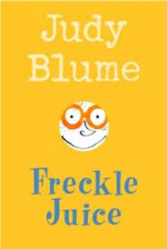
Required Book: Freckle Juice by Judy Blume
Required Assignments:
- After reading Freckle Juice, complete the three projects below.
- Book Cover/Book Jacket:
  - Imagine you are the author/illustrator of the book you are reading and you have been asked to generate a new cover for the book. What would it be?
  - Create a new cover for the book.
  - Include an alternate title.
  - Also include why you chose this new title and cover design.

- Story Board:
  - Create a story board.
  - Include at least 3-5 of the most important parts of the story. Draw a picture to illustrate each part.
  - Be sure to include information about the beginning, the middle and the end.
  - Also your story board should be in sequence (time) order.

- Letter Writing
  - Think of your favorite or least favorite character from the story.
  - Write a letter to that character about how you felt about their behavior or something they did in the story.

