Wilson Avenue School
Summer Reading Assignment
Students Entering 2nd Grade
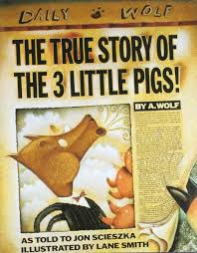
Required Book: The True Story of the Three Little Pigs by Jon Scieszka
Required Assignments:
- After reading The True Story of the Three Little Pigs, complete the three projects below.

- Advertisement/Poster:
  - Select your favorite part(s) of the story.
  - Illustrate this part of the story as a poster (be sure all your favorite parts are displayed).

- Story Board:
  - Create a story board.
  - Include at least 3-5 of the most important parts of the story. Draw pictures to illustrate each part.
  - Be sure to include information about the beginning, middle and the end.
  - Also, your story board should be in sequence (time) order.
- Letter Writing:
  - Think of your favorite or least favorite character from the story.
  - Write a letter to that character about how you felt about their behavior or something they did in the story.

