Wilson Avenue School
Summer Reading Assignment
Students Entering 1st Grade

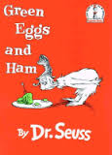

Required Book: Green Eggs and Ham by Dr. Seuss
Required Assignment:
- After reading Green Eggs and Ham, draw and describe a food that is as strange as green eggs and ham!

