STUDENT RESPONSIBILITIES
I, as the student who learns, will share the responsibility to improve my academic achievement and achieve the State’s high standards in the following ways:
- Actively participate in the learning occurring in class every day by being present and prepared.
- Complete my classwork and homework every day and ask for help when I need it.
- Give my parents or guardians all notices and information received by me from my school every day.
- Attend scheduled academic, before-school, after-school, Saturday, and summer programs and/or enrichment programs.
- Read at least 30 minutes every day outside of school time.
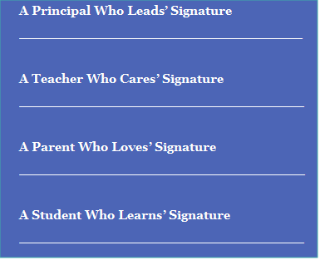



Roger León
Superintendent
NEWARK BOARD OF EDUCATION

President
Hasani Council

Co-Vice Presidents
Allison K. James-Frison
Vereliz Santana

Board Members
Kanileah Anderson
Josephine C. Garcia
Daniel Gonzalez
Dawn Haynes
Helena Vinhas
Crystal Williams

Where Passion Meets Progress

Hawkins Street School

HOME SCHOOL COMPACT
2024-2025



Mr. Alejandro Lopez
8 Hawkins Street
(973) 465-4920

PRINCIPAL RESPONSIBILITIES
I, as the principal who leads, will support student learning in the following ways:
- Provide opportunities for parents to discuss individual academic achievement during quarterly progress reports and at the Parent/Teacher Conferences scheduled on December 5th and February 13th.

- Encourage parents as full partners by providing ongoing communication through email, school newsletters, school apps, social media, BlackBoard Connect, student progress reports, and award ceremonies to encourage high student achievement.

- In addition to the Annual Title I Meeting, provide, at minimum, 2 monthly academic workshops for parents.

- Provide opportunities for parents to volunteer in school activities.

- Communicate in a language representative of parents in the school.

TEACHER RESPONSIBILITIES
I, as the teacher who cares, will support student learning in the following ways:
- Provide and implement high-quality instruction in a supportive and effective learning environment that enables children to meet or exceed the State’s student academic achievement standards.

- Monitor student academic growth, consistently assess student needs, and provide effective interventions for student success.

- Provide parents with frequent and timely reports on their children’s progress on October 2nd, January 7th, March 11th, and May 21st and during these report card distribution dates on December 5th, February 13th, May 1St, and June 24th.

- Provide parents opportunities to volunteer and participate in class activities.

- Ensure all instructional tools, resources and materials are used to meet students’ needs.

PARENT RESPONSIBILITIES
I, as a parent/guardian who loves, will support my child’s learning in the following ways:
- Stay informed about my child’s education and communicate with the school by promptly reading all notices from the school or the school district either received by my child, by mail, or by electronic communication and responding, as appropriate.

- Participate in all decisions related to my child’s education. This includes but is not limited to:
- Encourage school attendance and monitor student assignments and grades in PowerSchool.
- Become familiar with the curriculum and textbooks for my child’s grade level.
- Promote positive use of my child’s extracurricular time.

- Update the school of changes to student contact information so that I know of class or school information.

- Attend scheduled parent meetings.

- Volunteer and provide feedback on school policies, especially Title I.

