- Khan Academy  http://www.khanacademy.org/ | - Newark Public Library  http://www.npl.org/Pages/KidsPlace/New/index.html | - Sheppard Software  http://www.sheppardsoftware.com/
- Spelling city  http://www.spellingcity.com/ | - Starfall  http://www.starfall.com/ | - Math Playground  http://www.mathplayground.com/multiplication01.html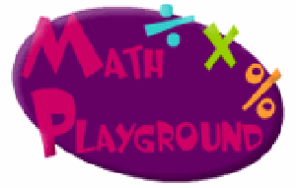
7. 3rd Grade Mr. Jameson Students Activities Menu  http://www.gvsd.org/page/872 | - Reading Skills Rocket  http://www.harcourtschool.com/menus/trophies/activities/reading_skills/reading_skills.html | 9. ABCya Kids Educational Computer Games & Activitieshttp://www.abcya.com/
10. Houghton Mifflin Hartcourt School Publishers All Subjectshttp://www.harcourtschool.com/index.html | 11. Dr. MLK Speech "I Have a Dream...."  http://www.teachertube.com/viewVideo.php?video_id=20916 | 12. I Have Been to the Mountaintop Full Speech  http://www.youtube.com/watch?v=ixfwGLxRJU8
13. President Obama’s 2013 State of the Union Speech (Transcript)  http://swampland.time.com/2013/02/12/president-obamas-2013-state-of-the-union-speech-transcript/#ixzz2KkMrjckDhttp://swampland.time.com/2013/02/12/president-obamas-2013-state-of-the-union-speech-transcript/ | 14. Learning Resources for home & School  http://www.bbc.co.uk/schools/ | 15. Dositey  http://www.dositey.com/2008/index-page-home.php
16. IXL  http://www.ixl.com/ | 17. A Fun Educational Website for Teachers and Students  http://www.apples4theteacher.com/ | 18. Create, read, and share visual stories  http://storybird.com/
19. BBC_Bitesize_Games_  Standard_Grade  http://www.bbc.co.uk/bitesize/standard/games/ | 20. BBC  http://www.bbc.co.uk/bitesize/ks1/maths/multiplication/play/ | 21. Visual Fraction  http://www.visualfractions.com/  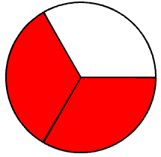
22. Brain Game  http://www.proprofs.com/games/word-search/onepiece-word-search-game/ | 23. In the News  http://hmhinthenews.com/ | 24. Fun Science & Technology for Kids  http://www.sciencekids.co.nz/gamesactivities.html

Common Core
http://schools.nyc.gov/NR/rdonlyres/8209508D-1B0D-4730-ABBE-3225611E13E8/0/NYCDOEG1LiteracyFrogs_Final.pdf
14. Broken Calculator
http://www.fi.uu.nl/toepassingen/00014/toepassing_wisweb.xml?language=en&publication=extern

