Uplift Academy
(Formerly known as Fast Track Academy)
150 Newton Street, Newark, NJ 07103

SCHOOL UNIFORM INFORMATION

Girls Uniform Description:
Black Pants, Skirts, Shorts, Bermuda shorts (no leggings)
Teal or Black Short Sleeve Polo Shirts w/ school logo
Teal Long Sleeve Polo Shirts w/school logo (starting in October)
White Short Sleeve Oxfords w/school logo
Black V-neck Cardigans w/school logo
Teal or Black Cross ties

Boys Uniform Description:
Use your
5%*
DISCOUNT
CARD
All Year Long!

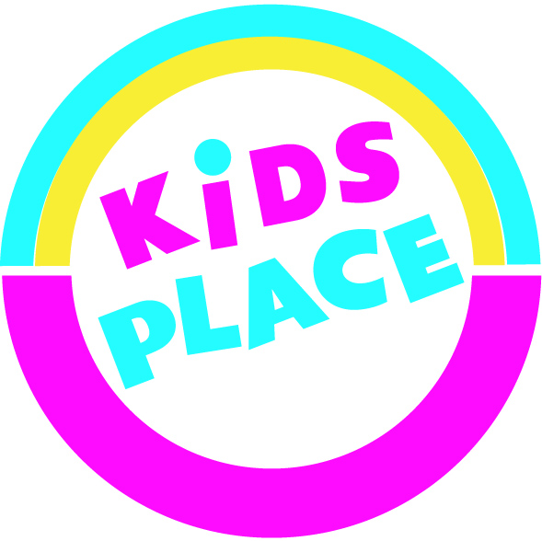
Black Pants or Bermuda shorts (no cargo pants)
Teal or Black Short Sleeve Polo Shirts w/ school logo
Teal Long Sleeve Polo Shirts w/school logo (starting in October)
White Short Sleeve Oxfords w/school logo
Black V-neck Cardigans w/school logo
Teal or Black Ties

Gym Wear – Boys & Girls:
Black or Teal Gym T-Shirts w/school logo
Black Sweat Pants w/school logo
Black Hooded Sweat Shirt w/school logo

*Note: All students must wear black uniform shoes
*Discount not applicable to sale items

Embroidered Uniforms

The Uplift Academy Embroidered School Logo must be on all the polo and oxford shirts. Each logo cost an additional $4.99.

“Ordering Embroidery”

Please order your embroidered school logos for uniforms in July! Order placed after August 10th will take 3-4 weeks to be completed. There will only be a limited supply of pre-embroidered uniforms available.
Uniforms are available at
the uniform shop @
KIDS PLACE
311 Ferry Street in Newark
(near Acme Supermarket in Ironbound area) or
126 Broad Street in Elizabeth (near train station)

Store Hours
Monday- Saturday 9:30am – 7pm
Sunday 11am – 6pm
All Major Credit Cards are accepted. (Layaways are available)

Shop online @ www.kpuniformshop.com
Visit us on Facebook theuniformshop@kidsplace

