Christopher D. Cerf
Commissioner of Education

For Immediate Release:
Contact: Communications Department
973.733.7338

NEWARK COMMUNITY UNITES TO STRENGTHEN
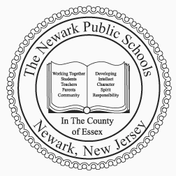
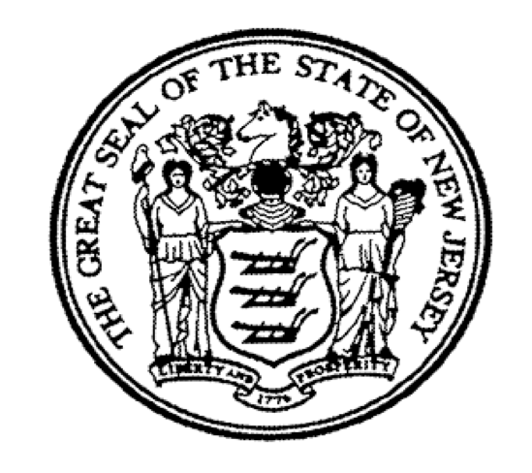
THE NEWARK PUBLIC SCHOOLS
Communications Department
2 Cedar Street
Newark, New Jersey 07102-3091
Phone: 973-733-7338
Fax: 973-733-7526

Cami Anderson
State District Superintendent

Matthew D. Frankel
Executive Director

ONE NEWARK PLAN

Newark Public Schools announces final refinements to
One Newark Plan

[Newark, NJ – February 7, 2014] – Concluding months of extensive outreach that has included many of the city’s civic leaders, community advocates, educators, local clergy, and families across public charter and district schools, Newark Public Schools (NPS) announced refinements to One Newark initiatives. Today’s announcements further the community-wide plan to ensure all students are in excellent schools and thriving communities and are on the path to excel in college and 21st century careers. Last December, under One Newark, NPS announced its ambitious goal to ensure 100 excellent schools in Newark, through the values of Excellence, Equity, and Efficiency.

“Our poorest neighborhoods, disproportionately African American, contain some of the lowest-performing public schools in the country and have for a long time,” said Newark Superintendent Cami Anderson. “A child in the South or West ward is virtually guaranteed to be in an elementary school where only 30 percent of students can read - or in a high school with a graduation rate below 30 percent that was built for 1500 students with only 500 kids enrolled. This is simply unacceptable. Good schools are in high demand -- over 5,800 families (and counting) completed an on-line application through One Newark Enrolls in just a few weeks (a new national standard). If we bring those good schools to the neighborhoods with the greatest need, we could revive schools and communities.”

“After extensive outreach, listening to families, and discussions with partners, elected officials, and other stakeholders we are pleased to announce some important updates and refinements to the One Newark plan,” said Ruben Roberts, Executive Director of Community Affairs and Community Engagement. “As part of our commitment to students and adults, we worked with partners to make adjustments in the charter launches and plans to revive our comprehensive high schools.”

- Charter Launches: We will transform 4 schools previously operated as district schools into charter-operated/partner-operated schools. Many partners have a stronger track record of success compared to NPS – even when you compare across subgroups. This plan does not add new charter seats – it redirects charter growth plans to neighborhoods demanding innovation. Currently, approximately 8,000 students are in public charter schools and 10,000 families are on waiting lists. In the South ward alone, 40% of families are applying for charters. As one example, many of families at Bragaw Avenue, which will become a TEAM Charter Launch, are on TEAM’s school enrollment waiting list. Important details about the charter launches are available at www.onewark.org.
- Comprehensive high schools: We must unite to address declining enrollment. Current data suggests that NPS will lose 2,000 out of 8,000 high school seats by 2016. Weequahic, West Side and Shabazz were built to serve 1,500 to 2,000 students each. Today, these schools collectively serve approximately 1,500 students. All trends indicate they will shrink to 400 students each next year. In the absence of bold solutions, two or three of our comprehensive high schools would have to close. We believe we must introduce innovative and attractive options that serve all students and fill buildings up to preserve these historic institutions. Important details about the comprehensive high schools are available at www.onewark.org.
- Learners in need of a second chance and NPS central headquarters: Each year, NPS spends over $4M in rent downtown. Simultaneously, the central office has engaged in conversations about being in closer proximity to our students. Specifically, we want to ensure we are supporting our students with the most needs. Therefore in fall 2014, NPS will move to the building that is currently Newark Vocational High School and share a campus with adults and young people in need of the greatest academic support. NPS Central will serve as the enrollment hub and reengagement center for disconnected youth and adult learners, the site for young people in need of short-term behavioral supports, the site for work-force and academic services for adults, and NPS’ central office. Important details about our commitment to learners in need of a second chance are available at www.onewark.org.

"I want my grandchildren to attend a really good school, and as it relates to Bragaw Avenue School, the One Newark Plan will preserve neighborhood schools as a viable option," stated Iris Torres, Parent-Teacher Organization President at Bragaw Elementary School.

“I appreciated hearing first hand, the contingencies and having the needs of our students, parents and our community addressed,” stated Eagle Academy parent, Keisha King. “As we continue to push forward in developing and creating a harmonious relationship, we are offering that same spirit of appreciation to NPS and are looking forward to working with the district.”

"BRICK looks forward to strengthening the partnership with NPS to meet the academic and social emotional needs of the children in the South Ward,” said Dominique Lee, Founder and Board Chair of B.R.I.C.K. Academy

“It’s about the district and the charter sector working together to ensure every child in Newark has access to a high-quality school, and the plans announced today represent a big, bold step in the right direction,” stated Mashea Ashton, C.E.O. of Newark Charter School Fund

"This important collaboration between the public charter school sector and the district will advance our shared commitment to providing every student access to a quality public school. Working together we have an opportunity to increase choice for all families in Newark,” said Ken Schultz, Executive Director of Newark Legacy.

"We started TEAM Charter Schools on Custer Avenue in the South Ward almost twelve years ago, and now have three schools in the South. We are excited to expand our commitment to the South Ward by offering the students of Bragaw Avenue School the opportunity to attend TEAM. And we are grateful to have been included in a plan that will increase the number of high quality school options for families in the South Ward and throughout all of Newark,” stated Ryan Hill, C.E.O., TEAM Charter Schools

"We look forward to working in partnership with the district to ensure that more students have access to a great public-school education,” said Julie Jackson, managing director of Uncommon Newark/Elementary Schools. “North Star has been committed to Newark families since our first school opened here in 1997 and we look forward to the opportunity to serve even more Newark students.”

"We all know that too many young people have dropped out of school in Newark -- becoming permanently disconnected from society. This One Newark strategy begins to open a door for thousands of the City's dropouts who have been invisible for too long,” stated Reginald Lewis, Executive Director of The Chad School Foundation, Inc.

“As the Principal, I talk with parents, students and the Weequahic alumni association frequently,” stated Weequahic High School Principal, Faheem Ellis. “Something that our Weequahic parents, the Weequahic alumni association, and I agree on is that we need to attract and keep students with programming that will make our kids ready for college and their future careers. The vision for Weequahic will be aligned to the district’s mission and will include the input and feedback from our school community.”

In addition to the One Newark details released today, a significant anchor of the One Newark plan is its universal enrollment system, which empowers all Newark families with the ability to choose their own schools across the district. Today’s announcement comes on the heels of yesterday’s data showing that nearly 5,800 families have made school selections thus far for school year 2014-15, far exceeding similar initiatives in cities such as Denver and New Orleans. Because of the overwhelming demand and interest, NPS has extended the due date for One Newark Enrolls to February 28, 2014. Families may continue to submit an application online at www.newarkenrolls.org or by filling out a paper application that can be obtained from and submitted to any district school, participating charter school or the NPS Central Office located at 2 Cedar Street.

# # #

