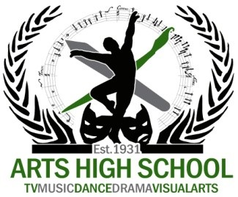

Registration Information for Incoming Arts High School Students:
This information is for students who have received official notice of acceptance to an Arts High School Program.
You will have 3 opportunities to register for enrollment at Arts High School:
- Saturday, April 30, 2016 Time: 9:00am – 12:00pm
- Tuesday, May 10, 2016 Time: 5:00pm – 7:00pm
- Thursday, May 12, 2016 Time: 5:00pm – 7:00pm
Please bring all required documents with you to registration.
- Proof of Residency (3 Required)
  - Voter Registration card
  - Financial account information
  - Federal/State/County identification
  - Deed/Mortgage statement
  - Property tax bill (last 6 Months)
  - Notarized Lead/Landlord Affidavit
  - Utility bills (Recent)
  - Driver’s License
  - Employment benefit documents

- Proof of Age (1 Required)
  - Birth Certificate
  - Baptism certificate (Original with date of birth)
  - Passport

- Immunization Records
Your child’s enrollment is NOT complete without
Proof of Residency, Proof of Age AND his/her Immunization Records.

